Release log space on secondary node during HANA Tenant Copy Command

SAP Note : https://me.sap.com/notes/2409471/E
2409471 - SAP HANA Log Volume Full on Secondary or Tertiary Site with System Replication

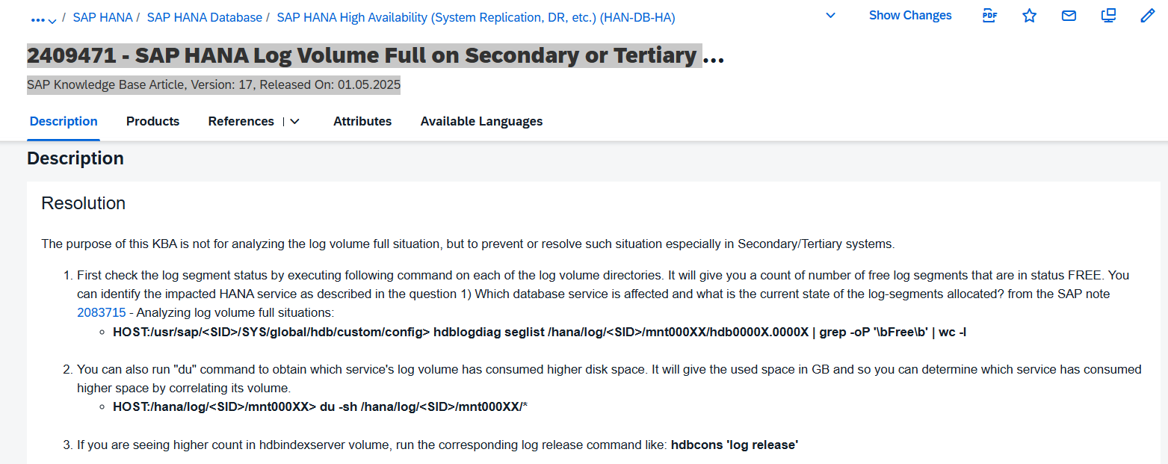
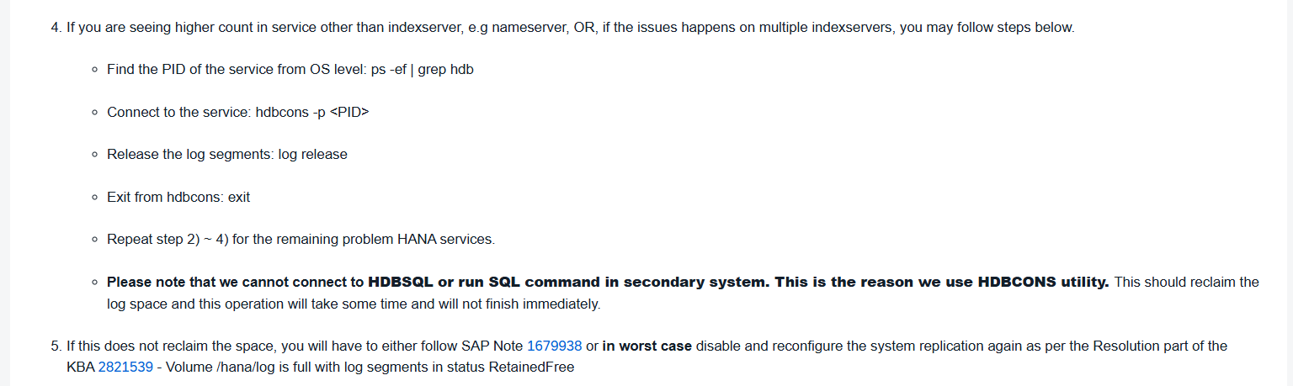

Issue
HANA Log FS on secondary node is getting full
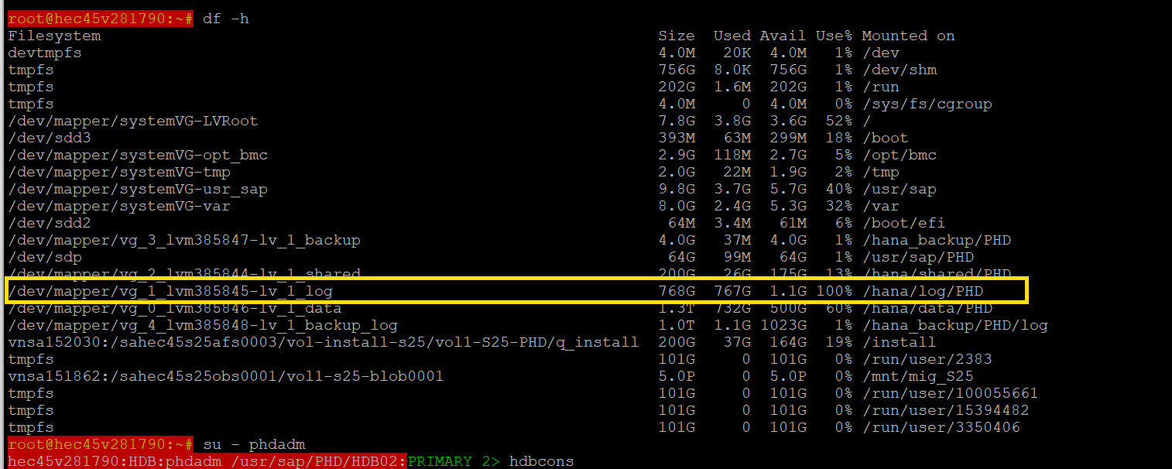
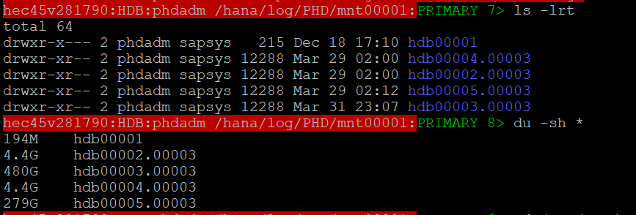
Executed command to check the free log segments
Execute on all the segments with huge size.

Once confirmed that log segments are free.
Release the logs

Steps to release the logs
- Find the process ID of the services – only services with persistence will consume logs
  - Which services have persistence – all services which are being replicated
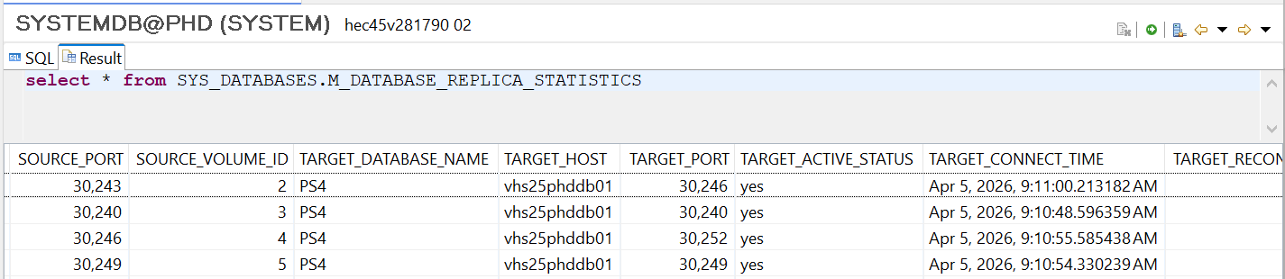
Find the services with port number
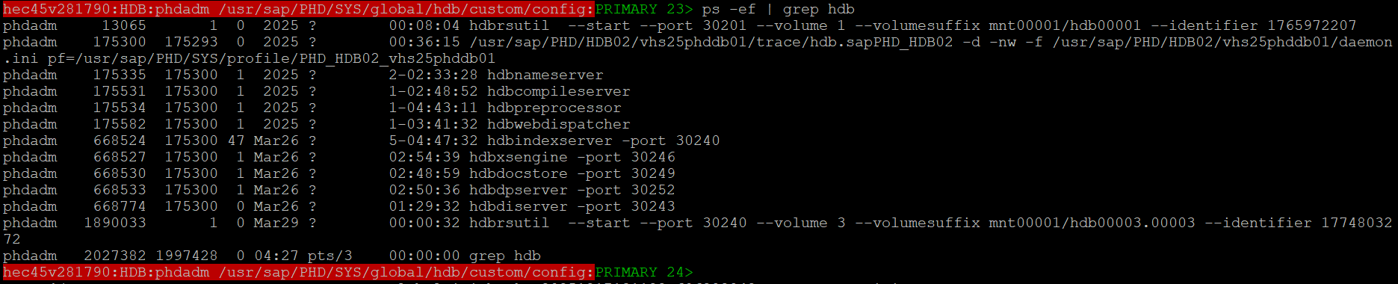
Services with port number 30246, 30240,30252,30249 are with persistence
- Execute hdbcons command to release the logs
  - Connect hdbcons to particular service : hdbcons -p <PID>
  - Release the log segments: log release
  - Exit from hdbcons: exit
  - Repeat step 2) ~ 4) for the remaining problem HANA services. 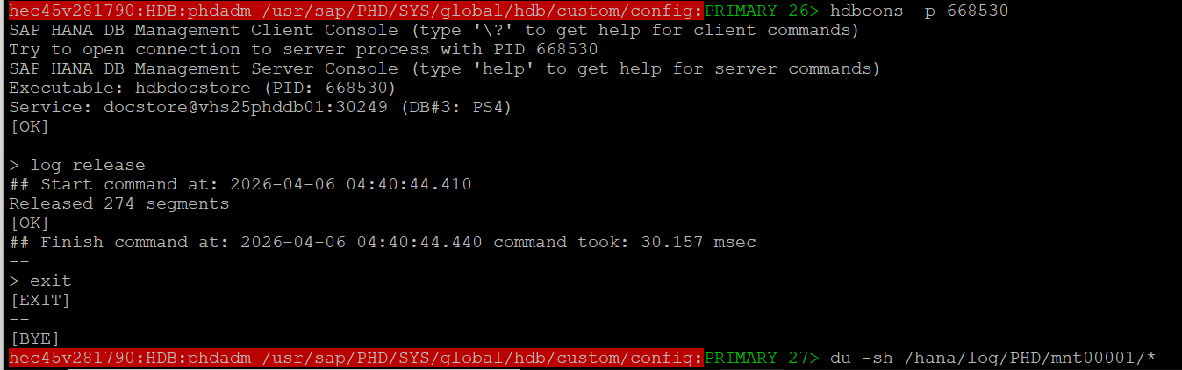 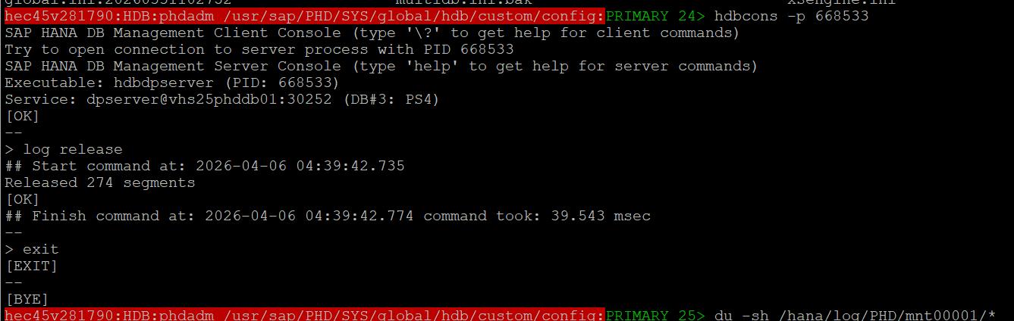 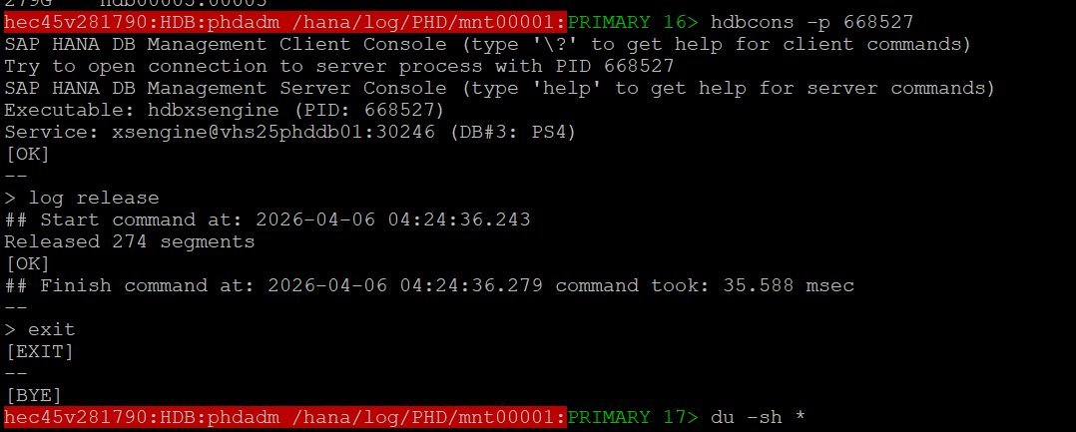
All the free logs have been released.
